**PRESS RELEASE**

**LOVE YOUR EYES" a children activity book remind of FHF-TIO friendship through Mithila arts**

On Tuesday, Australia’s Ambassador to Nepal, HE Felicity Volk and Dr Reeta Gurung, Chief Executive Officer from Tilganga Institute of Ophthalmology (TIO) launched an important new resource to promote eye health in children.

One thousand copies of a children’s activity book that delivers important messages about eye care, will be available in pediatric facilities at TIO. As young patients wait for treatment, they will now enjoy activity-based learning about eye health and the partnership between Dr. Sanduk Ruit of TIO and Australia's Dr.Fred Hollows to support health services in Nepal.

With funding from the Australian Embassy, the book was designed by Australia-based social entrepreneur and Rotarian, Ms. Sandra Fiedeldy and a team of Mithila artists from Relative Nepal. It continues a partnership among the Australian Embassy, TIO and Relative Nepal, that is employing traditional arts to promote both eye health and indigenous cultural arts.

Ambassador Volk said, “This book is both an appealing educational tool and a celebration of an enduring partnership between renowned eye specialists in Nepal and Australia, Dr. Ruit and Dr. Hollows, between TIO and the Fred Hollows Foundation and between the people of Nepal and the people of Australia. Also, she added “I commend Sandra Fiedeldy, the humble Australian behind this project. Sandra is determined to be of service to the people of Nepal – children, artists and health professionals alike.  She is an important part of the human bridge between our countries.”

Representing the artists, Executive Director of Relative Nepal, Mr.Jay Prakash Mandal thanked the Fred Hollows Foundation, TIO, the Australian Embassy and Sandra Fiedeldy for supporting Janakpur’s Mithila artists. He said, “Opportunities like these bring traditional Mithila arts to a global audience and help artists earn a living from their artistic practice.”

Dr. Reeta Gurung, Chief Executive Officer of TIO thanked the Australian Embassy, Relative Nepal and Sandra Fiedeldy for the books and hoped Nepal-Australia friendship will be stronger in the days to come.

18 June 2024

Media Contact:

[Krishna.karki@dfat.gov.au](mailto:Krishna.karki@dfat.gov.au)

**k|]; lj1lKt**

**æcfFvfnfO{ dfof ug{'xf]:f\Æ Ps afn lqmofsnfk k'l:tsf nf]sfk{0f**

d+unaf/, g]kfnsf nflu ci6«]lnofnL /fhb"t dxfdlxd\ km]lnl;6L ef]Ns / ltnu+uf cfFvf k|lti7fgsL k|d'v sfo{sf/L clws[t 8f= l/tf u'?Ëåf/f æcfFvfnfO{ dfof ug{'xf]:f\Æ gfds afnaflnsf nlIft cfFvf :jf:Yo k|jw{g ug]{ hgr]tgfd'ns k'l:tsf nf]sfk{0f ul/Psf]] 5 .

ci6«]lnofnL b"tfjf;sf] k|fof]hgdf ci6«]lnofnL ;fdflhs pBdL tyf /f]6l/og ;fG8«f lkm8]N8Lsf] kl/sNkgfdf l/n]l6e g]kfnsf lj1 ldlynf snfsf/x¿sf] snfåf/f tof/ o; k'l:tsf ltnu+uf cfFvf k|lti7fgsf] afn cfFvf pkrf/ ljefudf pkNfAw x'g]5g\ . Ps xhf/ k|lt k|sfzg ul/Psf] afn k'l:tsfaf6 pkrf/sf qmddf cfkm\gf] kfnf] klv{/x]sf afnaflnsfn] :juL{o 8f= k|m]8 xf]nf]h / 8f=;Gb's ?OtaLrsf] ldqtfsf] af/] ;d]t hfGg kfpFg]5g\ . b'tfjf;, ltnu+uf cfFvf k|lti7fg / cfkmGt g]kfnsf] ;xsfo{n] k/Dk/fut snfdfkm{t cfFvf :jf:Yo ;r]tgf / cflbjf;L ;fF:s[lts snfsf] k|jw{g ug]{ ck]Iff /flvPsf] 5 .

g]kfnsf nflu ci6«]lnofnL /fhb't ef]Nssf cg';f/ ;g\ !(() sf] bzssf] k|f/Deb]lv g} :juL{o 8f= k|m]8 xf]nf]h / 8f=;Gb's ?OtaLrsf] ldqtfsf] ;Demgf u/fpg] of] k'l:tsfn] c:6«]lnof / g]kfnaLrsf] hg–hgtfsf] ;DaGwnfO{ k|j4{g ug{ ;xof]u k'¥ofpg] cfzf ul/Psf] 5 . jxfFsf cg';f/ o; l;h{gzLn sfo{n] snfsf/x?sf] k|ltlglwTj ub}{ l/n]l6e g]kfnsf sfo{sf/L lgb]{zs hok|sfz d08nn] hgsk'/sf ldlynf snfsf/x?nfO{ lg/Gt/ ;xof]u u/]sf]df TIO, FHF, ci6«]lnog b"tfjf; / ;fG8«fnfO{ wGojfb 1fkg ug{'eof] . To:t} jxfFn] ,;fG8«f lkm8]N8]nLn] lg:jfy{ ?kdf g]kfnL afnaflnsfx?, snfsf/x? / :jf:YosdL{x?nfO k'¥ofpg'ePsf] ;xof]usf] k|z+;f ub}{ jFxf b'O{ b]zsf hgtfsf] ;'dw'/ ;DaGwsf] dxTjk"0f{ >f]t ePsf]df s[t1tf JoQm ug{'eof] .

snfsf/x?sf] tkm{af6 cfkmGt g]kfnsf sfo{sf/L lgb]{zs ho k|sfz d08nn] k|m]8 xnf]h kmfp08]zg, ltnu+uf cfFvf k|lti7fg, ci6]«lnofnL b'tfjf; / ;fG8«fnfO{ hgsk'/sf] ldlynf snfsf/x?nfO{ ;xof]u k'¥ofPsf]df wGojfb 1fkg ug{'eof] . Æo:tf cj;/x?n] k/Dk/fut ldlynf ldlynf lrqx?nfO{ ljZje/sf bz{sx?dfem k'¥ofpg / To;nfO{ cfosf] >f]tsf] ?kdf ljsf; ug{ d4t ug]{5Æ, jFxfn] eGg'eof] .

To:t}, ltnu+uf cfFvf k|lti7fgsL k|d'v sfo{sf/L clws[t 8f= l/tf u'?Ën] lstfa k|sfzgsf nflu ci6]«nLofnL b'tfjf;, cfkmGt g]kfn / ;fG8«f lkmN8]nLnfO{ wGojfb lbg'eof] . cfkm\gf] dGtJodf jxfn] Æo:tf lqmofsnfkx?n] g]kfn–ci6]«lnofsf] ;DaGw lj:tf/ ug{ d4t ug]{5 Æ pNn]v ug{'eof] .

४ असार २०८१

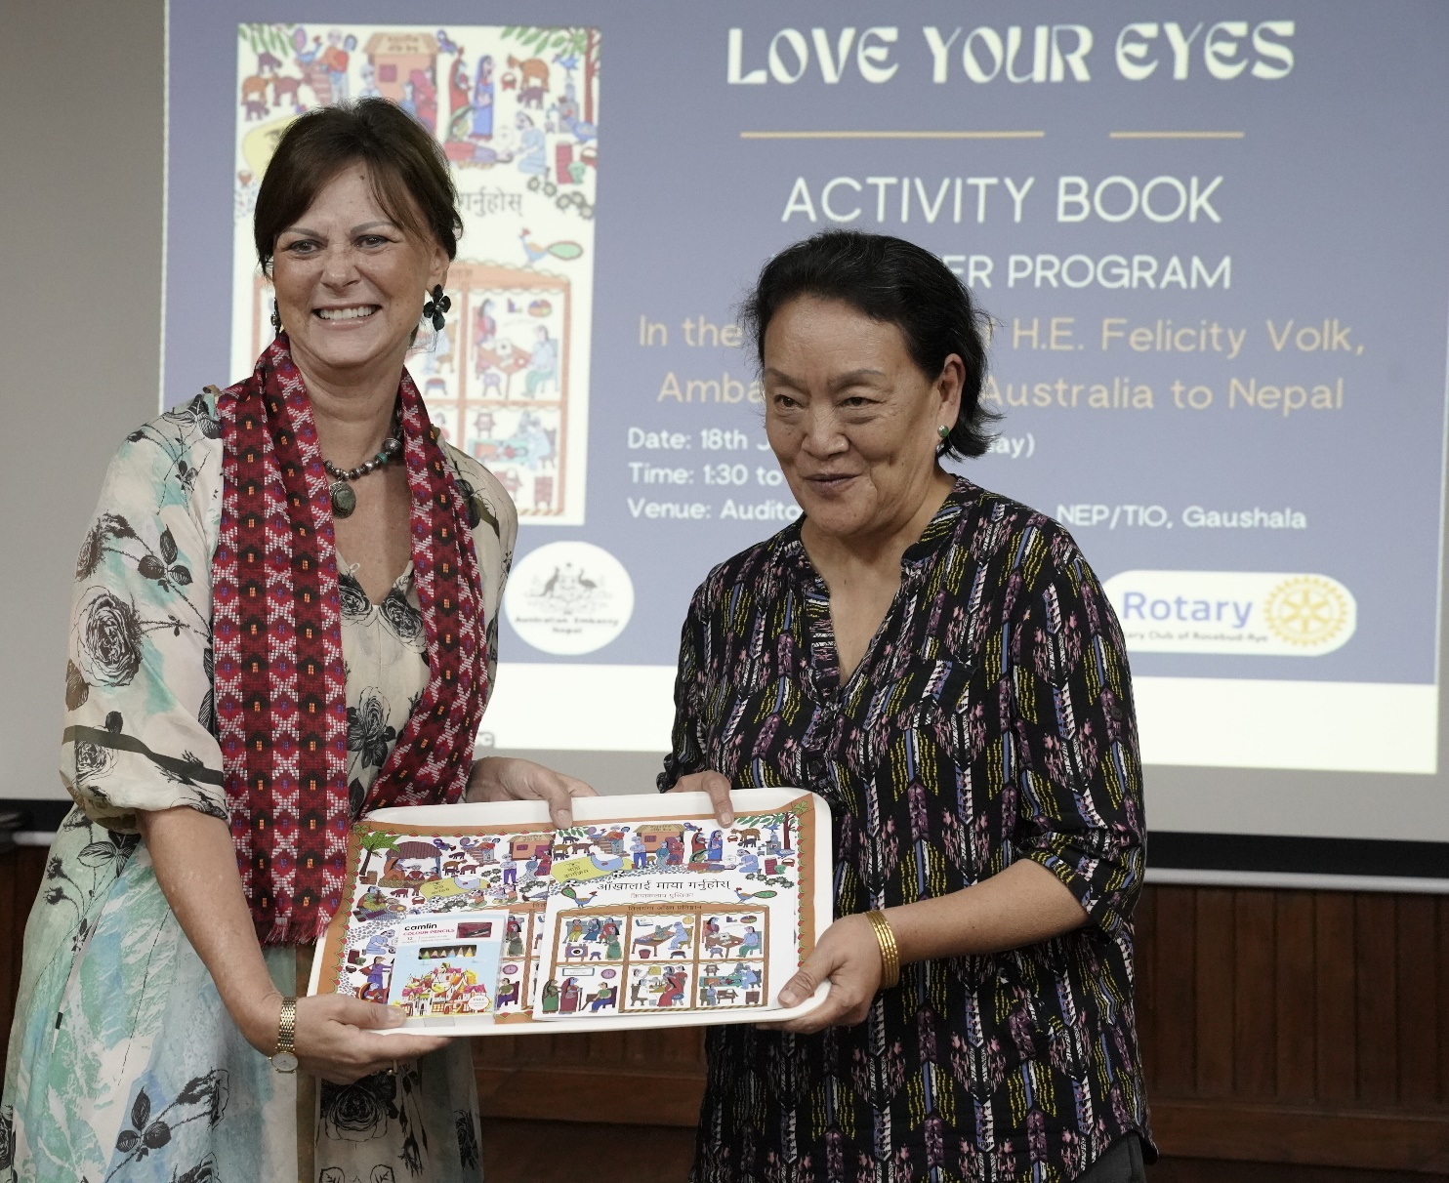

Australia’s Ambassador to Nepal, HE Felicity Volk (left) and Chief Executive Officer of Tilganga Institute of Ophthalmology (TIO)   
Dr Reeta Gurung launch Love your Eyes Children’s Activity book at an event in Kathmandu on Tuesday. Photos: TIO

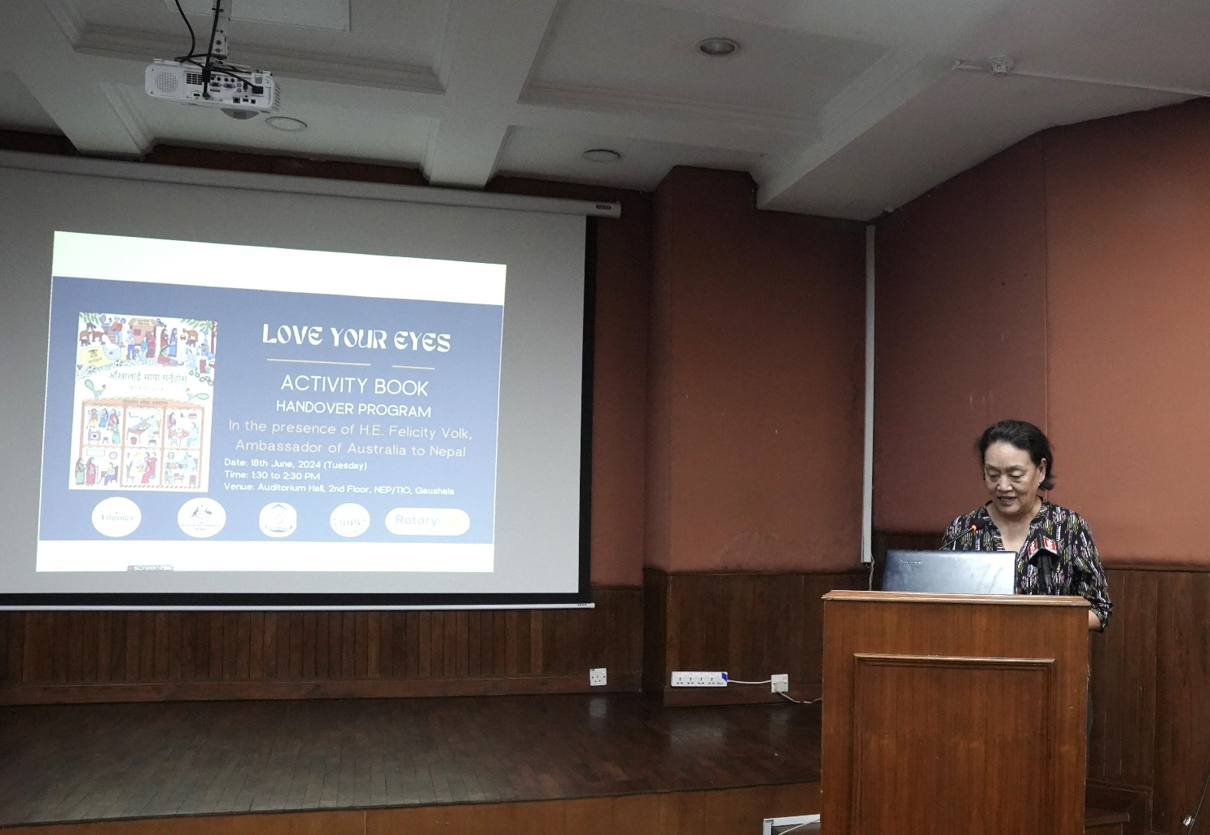

Chief Executive Officer of Tilganga Institute of Ophthalmology, Dr Reeta Gurung addressing an event organised to launch a book Love Your Eyes Activity Handbook on Tuesday. Photo: TIO